**Data Model for Toyota Car Trends   
Between 2015 to 2019**



OPMT 7750 Data Modelling & Business Intelligence

­

Prepared for Shauna Begley

Assignment 5



Group 3­­­



Monika Szucs A00878763

Alireza Dehghan A01168055

Taralynn Reburn A00657762

March 26, 2022

## **Company Overview & Background**

Headquartered in Toyota City, Acichi, Japan lies the Toyota Motor corporation which is a Japanese multinational automotive manufacturer. On August 28th, 1937, Kiichiro Toyoda founded and incorporated the Toyota Motor Corporation. Toyota produced about 10 million vehicles per year and was one of the largest automobile manufacturers in the world. Over the five years from 2015 to 2019, Toyota sold 3.65 million vehicles within Canada.

In March 2020, prior to their new fiscal in April, Toyota Canada is currently dealing with a reduction of new vehicle inventory on the market due to the shortage in computer chips worldwide, which is heavily impacting the vehicle industry. Toyota Canada has identified 7 models which require the most amount of microchips, and want to understand if they should pause production on any. We will review production and sales history, between 2015 to 2019, along with vehicle recall and repair requirements in order to provide a recommendation of which vehicles to focus on producing and which to pause until the microchip shortage is no longer an issue. Data from where vehicles are purchased across the country will support the direction of where to deploy the completed vehicles to fulfill the sales order requirements.

## **Problem Statement**

How can Toyota Canada better understand trends within its own brands sales and repair history to identify the best models and locations to deploy for 2020 sales?

## **Analytic Questions**

|  |  |
| --- | --- |
| **Analytic Question(s)** | **Why is the answer to this question important? Think, “so what?”** |
| What are the top 7 selling models for Toyota? | Toyota Canada wants to understand the most popular vehicles so they can focus production on them. |
| Which Region in Canada sells the most Toyota vehicles overall? | Toyota Canada needs to better understand where to deploy their completed vehicles. |
| Which model has caused the most amount of repairs? | Toyota needs to better understand recall trends to understand which model may cost them the most in the future. |
| What are the profit margins on different models? | Toyota Canada wants to understand which models have potential to yield higher overall revenue |
| Which model is projected to have the least impact on Toyota profit for 2020? | Understanding recall trends will assist with which cars to focus on producing. |

## **Process & Limitations**

Data was downloaded from one web site to receive the total number of Toyota vehicles sold within Canada during the 5-year period. Due to limitations around sourcing the number of specific Models, this data was created manually and calculated based on population research. The cost of repairs and MSRP per Model was also created manually, based on research and combining different datasets. Information about the data sources is found in the below tables.

## **Data Source 1 - Repairs**

|  |  |
| --- | --- |
| Reference | https://wwwapps.tc.gc.ca/Saf-Sec-Sur/7/VRDB-BDRV/search-recherche/results-resultats.aspx?lang=eng&mk=39384!2474!2734!38933&mkName=TOYOTA&md=0&fy=2011&ty=2020&ft=&ls=0&sy=0&syName=All%2520Systems&all=0 |
| Source Format | Table |
| Data Fields | Model (text)  System (text)  Year (year)  Model Year Effected (number) |
| Primary Key | Merged Column > Model | Year |
| Relationship | Linked to Year and Model via Primary Key |

## **Data Source 2 - Units Sold**

|  |  |
| --- | --- |
| Reference | Inspired by:  <https://public.tableau.com/app/profile/icbc/viz/VehiclePopulationIntroPage/VehiclePopulationData>  <https://global.toyota/en/company/profile/production-sales-figures/>  <https://www150.statcan.gc.ca/n1/pub/92-195-x/2011001/geo/prov/tbl/tbl8-eng.htm> |
| Source Format | EXCEL |
| Data Fields | ModelName(Text), Year(Year), YearID(AutoGen), ModelID(AutoGen), Province&Territories(Text), RegID(AutoGen) , VehiclePopulation (number) |
| Primary Key | Merged Columns > ModelID | YearID | RegID |
| Relationship | Linked to Repairs and Profit via Primary Key |

## **Data Source 3 - Profit**

|  |  |
| --- | --- |
| Reference | None (Created) |
| Source Format | Table |
| Data Fields | Sale­sID, SalesLocation, SalesDate, Cost, MSRP, SalesAmount, ModelCode, Region, KeyCities |
| Primary Key | Merged Columns > Year | Model | Price |
| Relationship | Linked to Year, Model, and Price via Primary Key |

The data sources that we have collected will be formatted using the Excel Power Query editor. We will showcase how each of the main tables repairs, units sold, and profit each contribute to the problem statement. The relationship among these data sources are as illustrated below:

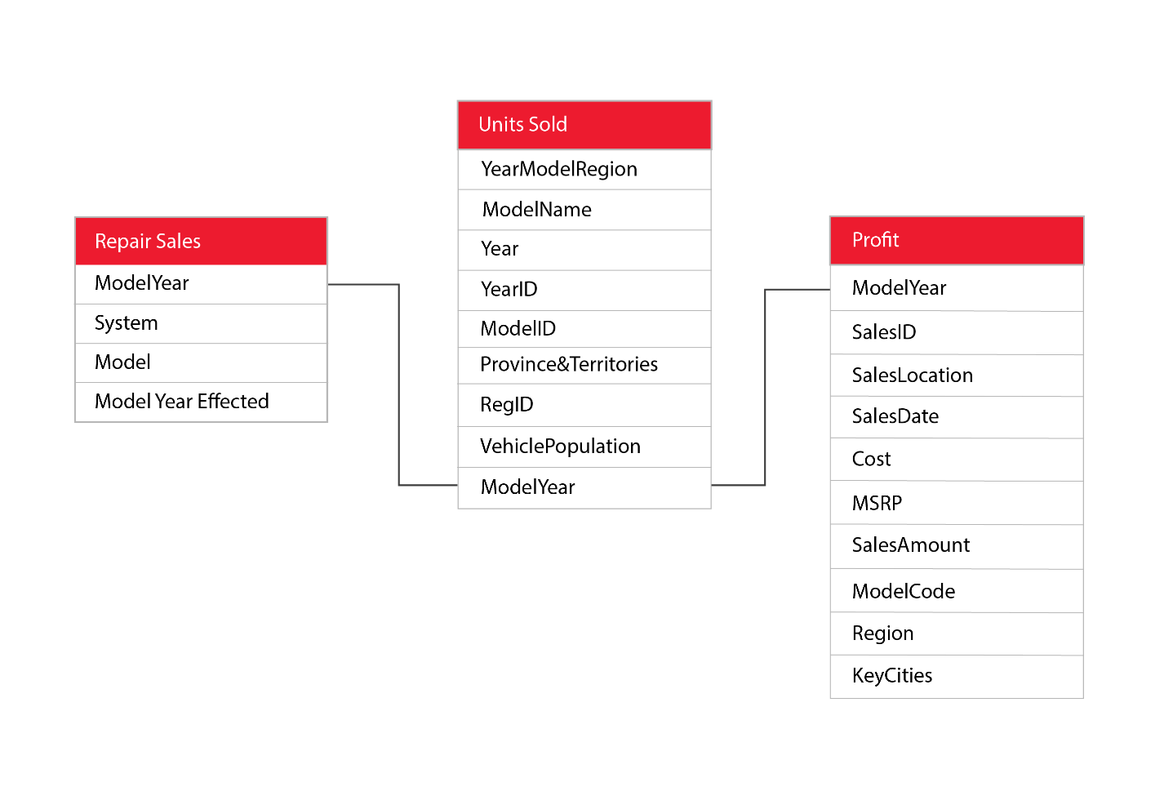

## **References**

Canada, T. (2022, March 26). *Motor Vehicle Safety Recalls Database*. From Government of Canada: https://wwwapps.tc.gc.ca/Saf-Sec-Sur/7/VRDB-BDRV/search-recherche/results-resultats.aspx?lang=eng&mk=39384!2474!2734!38933&mkName=TOYOTA&md=0&fy=2011&ty=2020&ft=&ls=0&sy=0&syName=All%2520Systems&all=0

News, B. (2022, February 9). *Global chip shortage: Toyota profits fall as production hit*. From BBC News: https://www.bbc.com/news/business-60313571

Obafemee80. (2021, November 12). *AutoJosh News*. From NEWSThe Toyota Motor Corporation : The Founder, Headquarter, Products And Other Things You Need To Know: https://autojosh.com/toyota-motor-corporation/

*Tableau Public*. (2020, July 26). From Vehicle population data: https://public.tableau.com/app/profile/icbc/viz/VehiclePopulationIntroPage/VehiclePopulationData

*Toyota*. (2022). From Sales, Production, and Export Results: https://global.toyota/en/company/profile/production-sales-figures/